Abstract Template: Title-Case, Centered, and Arial 12 Points

Taro Yamada,¹ Ming Xing,² and Given N. Family^{1,3,}*

¹ Department of Ceramic Science and Technology, Tokyo University, Tokyo 113-8035, Japan
² Ceramic Product Division, Japan Ceramic Co. Ltd., Okinawa 385-2959, Japan
³ Materials Analysis Group, National Institute of Advanced Ceramics, CA 20052, USA
*Corresponding author, e-mail: ceramic@tky-univ.ac.jp

The abstract must not exceed one page and should be prepared in the following format: (1) Use a sheet of A4 size paper. Fonts, sizes and spacing should be used as they are used in this document. (2) Use 10.5 points Times New Roman for the main text and figure captions. (3) Title (Arial, 12 pt.), author’s names (Times New Roman, 11 pt.), affiliations, and corresponding author’s e-mail address should be centered. Please underline the presenting author. (3) Do not delete the line between the affiliations and the main text. (4) The abstract may contain figures, schemes or tables. It should be noted that all the accepted abstracts will be electronically distributed to participants in digital media such as USB memory or DVD.

Please convert this document to a PDF file and send it by email to the conference secretary.

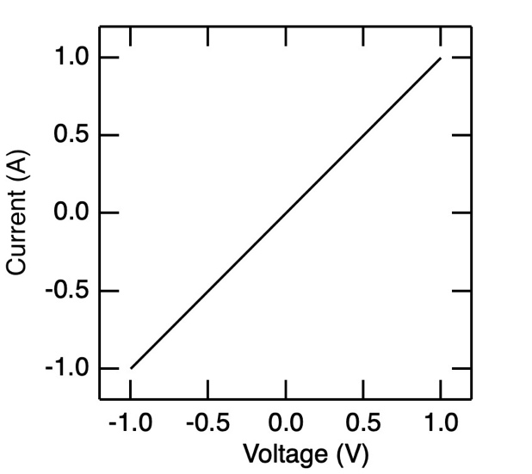
Fig. 1 Voltage vs current plot.

References
[1] J. G. Caporaso, Y.-J. Chen, F. D. Bush Jr., Science 251 (1998) 6410.
[2] M. Suzuki, J. Tanaka, Phys. Rev. B 47 (2018) 14835.

